Market and Patent Research Report
Topic: Autonomous Robotic Systems for the Removal of Invasive Plant Species
Case Study: Giant Hogweed and Similar Neophytes
Course: Product Development – From Need to Market
Institution: Hochschule Kaiserslautern
Semester: SS 2025

1. Introduction
Invasive alien plant species such as Heracleum mantegazzianum, Lupinus polyphyllus, and Jacobaea vulgaris pose significant environmental and public health challenges in Europe. These plants negatively affect native biodiversity, outcompete local flora, and may pose toxicological risks to humans and animals. Conventional removal methods rely on herbicides, which are increasingly restricted by EU environmental legislation (e.g., Regulation (EU) No. 1143/2014), or labor-intensive mechanical clearing.
Recent advances in agricultural robotics provide an opportunity to address this issue using autonomous systems that employ machine learning, vision technologies, and non-chemical removal techniques, including electric pulse applications.

2. Market Overview and Technological Landscape

2.1. RootWave (UK) – Electric Weed Control System
- Technology: Applies high-frequency electric pulses through contact probes to thermally destroy plant cells from root to tip.​
- Target Species: Effective on deep-rooted perennials including Heracleum mantegazzianum.​
- Advantages:
  - Non-chemical and environmentally safe.​
  - Minimal soil disturbance.​
  - Suitable for robotic integration.​Carbon Robotics
- Use Cases: Municipalities, ecological reserves, organic agriculture.​

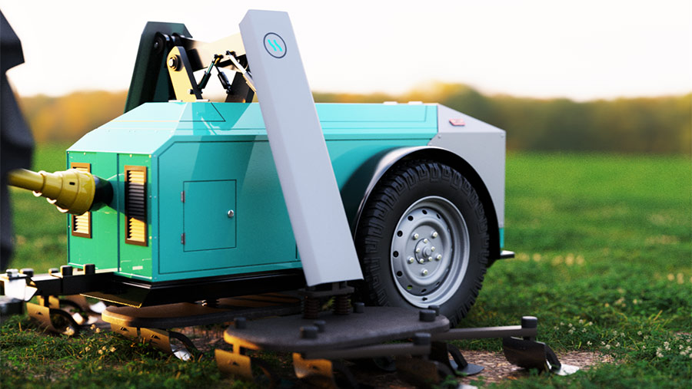
Figure 1 (Source: RootWave)

- Video Demonstration:
RootWave Demonstration​1
RootWave Demonstration​2

2.2. Carbon Robotics – LaserWeeder

- Technology: AI-powered machine vision with mounted CO₂ lasers for precision weed eradication.​
- Target Species: More suitable for row crops. Not designed specifically for tall or toxic plants like hogweed.​
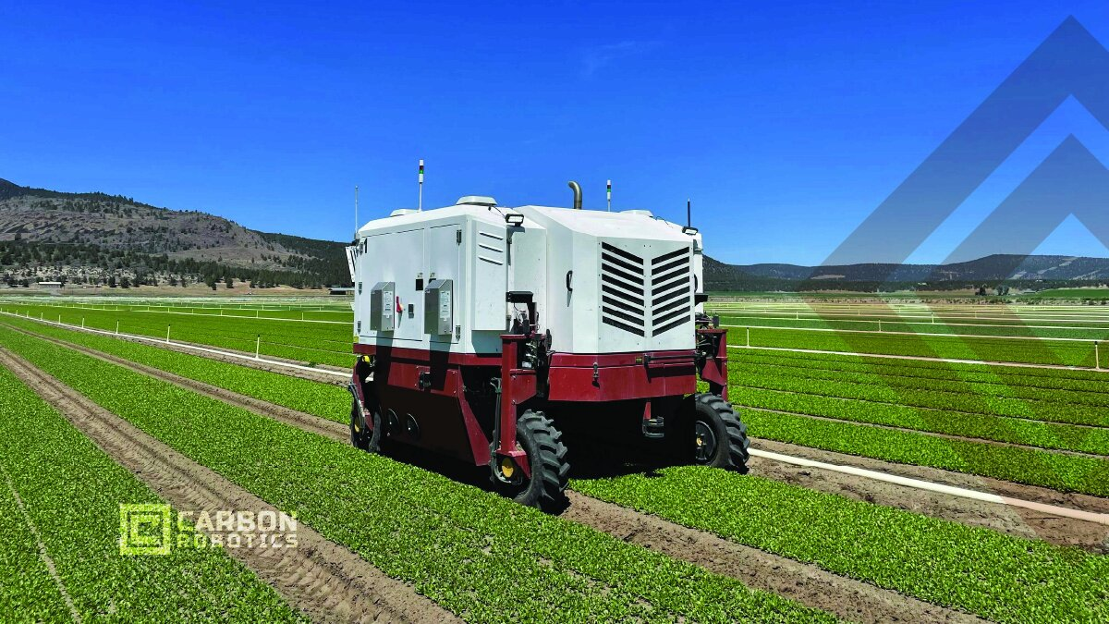
Figure 2 (Source: Carbon Robotics)
- Video Demonstration: LaserWeeder Overview​

2.3. Odd. Bot – Weed Pulling Robot (NL)
- Technology: Selectively detects and pulls weeds using robotic grippers, based on image classification algorithms.​
- Target Species: Applicable for broadleaf weed species like Jacobaea vulgaris.​

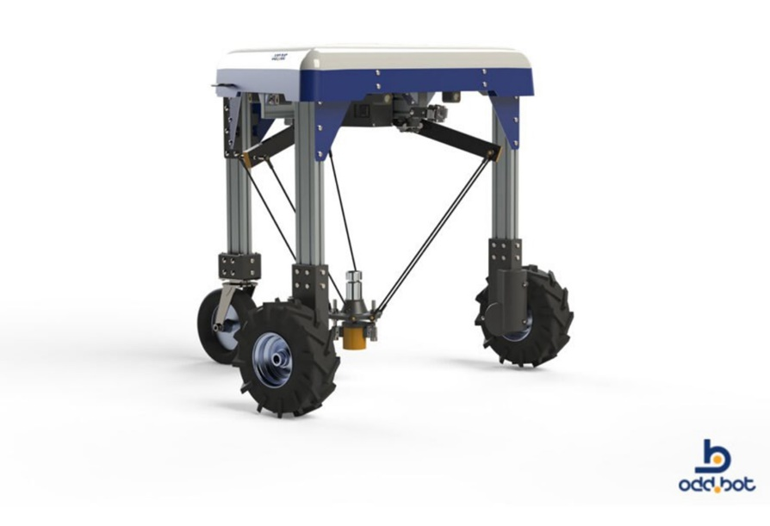
Figure 3 (Source: OddBot)

2.4. Drone and Aerial Detection Platforms (DK, DE, UK)

- Technology: Drones combined with NDVI, hyperspectral imaging, or machine learning can map infestations of hogweed in open fields and forests.​
- Advantages: Ideal for pre-mapping and targeting robotic ground intervention.​

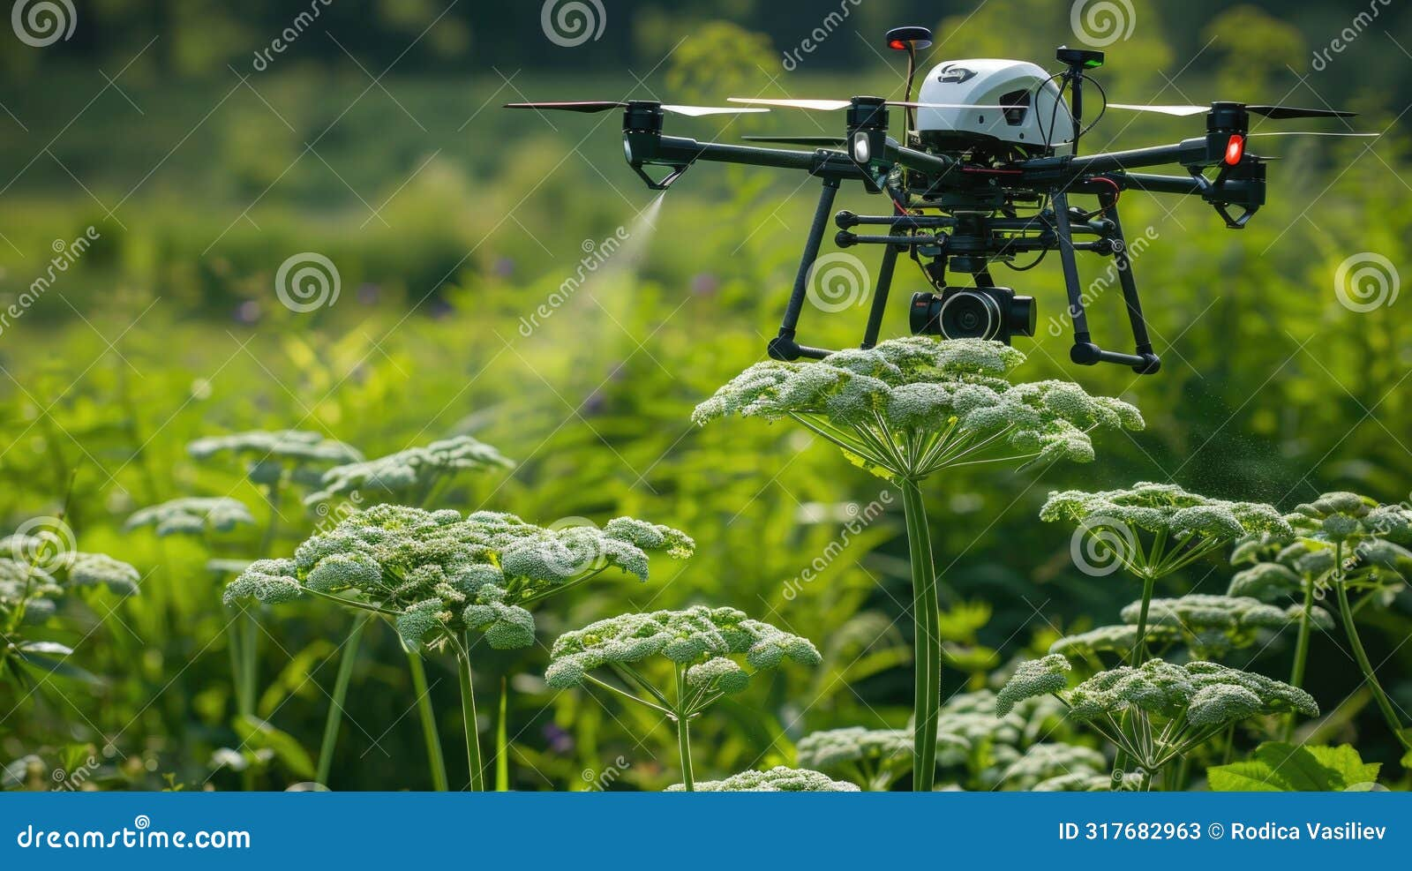

2.5. FarmWise – Titan FT-35 (USA)
Manufacturer: FarmWise
Technology: A self-driving robotic cultivator equipped with multi-camera computer vision, trained artificial intelligence (AI), and a mechanical blade system. The robot identifies and mechanically removes weeds between crop plants. It can optionally be configured to apply small doses of fertilizers or pesticides using its precision control system.
Target Species: Broadleaf weeds in vegetable crops.
Use Cases: Commercial vegetable farms focused on precision, chemical-reduced weeding and cultivation.

2.6. Naïo Technologies – Dino (France)
Manufacturer: Naïo Technologies
Technology: Dino operates autonomously using GPS navigation, laser scanners, and onboard cameras to localize itself and follow crop rows. The robot is equipped with adjustable mechanical harrows and hoeing tools to perform inter-row mechanical weeding. Advanced versions integrate computer vision similar to the company’s Oz robot, enabling selective recognition of crop plants to avoid damage during operation.
Target Species: Weeds between and near crop rows in open fields.
Use Cases: Organic farms requiring high-precision, non-chemical weeding.

2.7. ecoRobotix – AVO (Switzerland)
Manufacturer: ecoRobotix
Technology: AVO is a solar-powered, autonomous robot that uses ground-level cameras and machine learning algorithms to distinguish weeds from crops. When a weed is detected, a robotic arm applies a micro-dose of herbicide via a precision spray nozzle directly onto the weed. This minimizes chemical usage and collateral damage. Initial field applications include sugar beet and canola.
Target Species: Isolated weeds among broadleaf crops.
Use Cases: Sustainable farming with minimized herbicide deployment.

2.8. FarmDroid – FD20 (Denmark)
Manufacturer: FarmDroid
Technology: This system records the precise GPS coordinates of each seed at the time of sowing. During weeding, the robot performs blind mechanical cultivation both between and within rows, using hoeing tools to eliminate any vegetation not located at the predefined crop positions. It requires no cameras and operates fully on solar power.
Target Species: Early-stage weed seedlings throughout crop fields.
Use Cases: High-efficiency organic grain and vegetable farms with grid-pattern planting.

2.9. Small Robot Company – “Tom & Dick” (UK)
Manufacturer: Small Robot Company
Technology: This dual-robot system consists of Tom, a scouting robot that maps fields with cameras and forwards data to an AI platform (“Wilma”), and Dick, a robotic weeder that uses an electrical weeding tool. Dick navigates to weed positions and applies a ~8000-volt electric shock through an electrode probe, boiling the weeds from the root. It uses an Igus delta robotic arm for accurate positioning, and multiple arms can operate in parallel for increased efficiency.
Target Species: Broadleaf weeds in high-value or densely planted crops.
Use Cases: Environmentally responsible, non-chemical precision agriculture.

2.10. AutoWeed – Lantana Targeting Robot (Australia)
Developer: James Cook University (JCU) (AutoWeed)
Technology: Developed as a university research project, this prototype robot uses eight cameras and onboard AI to identify Lantana camara, a major invasive plant in Australia. It applies a localized herbicide spray to identified targets using color, texture, and shape-based recognition. Navigation is currently semi-autonomous, guided by an ATV, and includes GPS geotagging of treated plants for monitoring.
Target Species: Lantana camara in open or mixed terrain.
Use Cases: Biodiversity protection in reserves and rangeland control operations.

2.11. BirdHabitatBot – Forest Invasives Robot (USA)
Developer: University of Connecticut (BirdHabitatBot)
Technology: This system integrates aerial drone surveys with an autonomous ground robot for invasive shrub control in forests. Drones detect early spring leaf-out from species like Japanese barberry and multiflora rose, generating a GPS map. The BirdBot ground unit follows these coordinates and removes the invasive shrubs by cutting them at the base. It is designed to traverse rough terrain and forest understory.
Target Species: Invasive Forest understory plants (e.g., Japanese barberry, multiflora rose).
Use Cases: Forest conservation and habitat restoration projects.

2.12. Bosch Deepfield – BoniRob (Germany)
Developer: Bosch Research (BoniRob)
Technology: BoniRob is a vision-guided agricultural robot that distinguishes seedlings by leaf shape. It uses a pneumatic actuator to punch weeds into the ground, a technique termed “stamping.” The method is entirely chemical-free and highly fast, removing up to 1.75 weeds per second. This robot remains in prototype stage and is optimized for use on very young weed stages.
Target Species: Early-stage seedlings in uniform planting conditions.
Use Cases: Experimental high-speed non-chemical cultivation in structured test plots.

2.13. Hydrilla Hunter – Robotic Boat (USA)
Developer: Northeastern University & Connecticut Agricultural Experiment Station (Hydrilla Hunter)
Technology: An aquatic robot equipped with hyperspectral imaging to detect and identify invasive aquatic plants like Hydrilla verticillata based on their spectral signatures. Once mapped, the boat autonomously navigates to these locations and assists in manual or robotic weed removal operations.
Target Species: Aquatic invasive plants (Hydrilla, Eurasian watermilfoil).
Use Cases: Lake and river ecosystem protection in freshwater habitats.

Comparison Table of Weed Removal Robots
Robot (Origin) | Environment & Use | Recognition & Mapping | Removal Mechanism | Key Pros | Key Cons
Carbon LaserWeeder G2  (USA) | Farming – row crops (vegetables, row herbs) | Cameras + deep-learning AI distinguish crops vs weeds | 8× high-powered lasers “zap” weeds (no contact) | No herbicides; no soil disturbance; fast, day/night​ | Expensive; heavy tractor mount; limited to spaced row crops
FarmWise Titan FT-35  (USA) | Farming – vegetable fields | Multi-cameras + AI model trained on millions of images | Automated blades cut weeds around crop plants | Chemical-free weeding; adaptable to many crops; as-a-service model | Large machine; requires row structure; service fees (not owned)
Naïo Dino  (France)​ | Farming – vegetable bed weeding | GPS guidance + front laser/camera for row positioning​ | Mechanical cultivator blades/hoes uproot weeds | Battery-electric (6–8h); reduces hand labor; multi-task capable | Heavy unit; high upfront cost; mainly inter-row (in-row weeds harder)
ecoRobotix AVO  (Switzerland) | Farming – precision spot-spraying | Camera vision + AI to detect weeds among crops | Micro-dose herbicide sprayer on robotic arm | Solar-powered; uses 95% less herbicide; light & low compaction | Slow coverage; limited initial crop/weed range; not for tall crops
FarmDroid FD20  (Denmark) | Farming – seeding & weeding | RTK GPS maps crop seed positions (no vision needed) | Tiny harrows weed between and within rows mechanically | No camera needed (simple); zero chemicals; 24/7 solar run | Must use robot for planting; slow but steady; limited to row crops
Small Robot Co. Tom/Dick  (UK) | Farming – arable crops (trials) | “Tom” maps field with cameras; AI (Wilma) identifies weeds | “Dick” robot zaps weeds with 8kV electrical probe | No herbicides; can selectively leave benign plants; little soil impact | Prototype stage; two-step process is time-consuming; complex multi-robot system
AutoWeed Lantana Robot  (Australia) | Rangeland/Forestry – invasive shrubs | 8 RGB cameras + AI vision (color/shape/texture) find target weed | Sprays herbicide on detected weed foliage via nozzle | Cuts labor & cost for weed crews; 90% ID accuracy in tests | Prototype (tethered in tests); uses chemicals; terrain navigation challenges
BirdHabitatBot  (USA) | Forestry – understory invasives | Drone aerial imagery + deep learning to map invasive shrubs | Ground robot drives to locations and cuts shrubs at base | Targets only invasives (protects natives); keeps workers safe | Experimental; rough terrain obstacles; may need supplementary herbicide for stumps
Hydrilla Hunter  (USA) | Aquatic – freshwater weeds | Hyperspectral camera detects unique spectral signature | Marks GPS coordinates of hydrilla patches (for later removal) | Automates weed surveys; very species-specific (few false alarms) | Doesn’t remove weed itself; limited battery; one-species focus (Hydrilla only so far)
Bosch Deepfield “BoniRob”  (Germany) | Farming – research prototype | Camera vision distinguishes weed seedlings by leaf shape | A piston punches weeds into soil (“stamping” method) | No chemicals; very fast actuation (up to 1.75 weeds/sec) | Prototype not commercialized; requires small weed size; heavy platform with generator

3. Patent Research Overview

3.1. EP3804483A1 – Tool for Eradication of Invasive Hogweed Species

- Assignee: Søren Lauritzen (Denmark)​
- Description: This patent describes a manual stem-puncturing tool designed to induce necrosis in giant hogweed (Heracleum mantegazzianum) without fully severing the stem. By damaging the vascular tissues, the tool minimizes regrowth potential.​
- Significance: Provides a basis for potential robotic adaptation using automatic puncturing probes for targeted invasive species control.​
- Link: Patent EP3804483A1​

3.2. WO2021055485A1 – Autonomous Laser Weed Eradication System

- Assignee: Carbon Robotics​
- Description: This patent outlines a robotic platform equipped with sensors and a vision system that guides a laser source to ablate unwanted plants.​
- Limitation: The system is not optimized for toxic plants or non-row field applications, limiting its applicability to certain invasive species.
- Link: WO2021055485A1​

3.3. US20170238460A1 – Weeding Robot and Method

- Assignee: Blue River Technology​
- Description: This patent describes a selective weeding robot that utilizes capacitive and optical sensors for precision removal of weeds using mechanical tools.
- Potential Use: The platform is adaptable for differentiating and removing invasive species in various agricultural settings.​​
- Link: US20170238460A1​

3.4. EP3744173A1 – Weed Inactivation Device Using Electric Pulses

- Assignee: Zasso GmbH (Germany)​
- Description: This patent details an electrically driven weed inactivation device that uses contact electrodes to deliver high-voltage pulses, effectively destroying plant tissues.
- Relevance: The technology can be integrated into autonomous platforms for field use against large invasive targets, offering a non-chemical alternative for weed control.
- Link: EP3744173A1

3.5. DE102015209879A1 – Device for Damaging Weeds

- Assignee: Bosch GmbH (Germany)​
- Description: This German patent proposes a device comprising a processing tool designed to damage weeds, a classification unit to recognize weed positions, a localization unit to determine the relative position between the tool and the weed, and a manipulator unit to position the tool accordingly.​
- Significance: The system enables precise, rapid, and chemical-free weed control, potentially adaptable for robotic applications targeting invasive species.​
- Link: DE102015209879A1
3.6. DE4039797A1 – Weed Control Device

- Assignee: Robert Bosch GmbH
- Description: This patent describes a device for weed control in which an actuator for destroying the weeds operates continuously and is briefly interrupted only when a sensor detects a crop plant.​
- Significance: The technology allows for continuous weed removal with minimal crop interference, suitable for integration into automated systems for invasive plant management.​
- Link: DE4039797A1

